KY STEM Brief from the Kentucky Academy of Science
October Issue: PFAS
10/22/2025
Science and technology are ever-changing, and new developments require sound legislation. The Kentucky Academy of Science (KAS) is a local resource for scientific knowledge right here in the state of Kentucky. Each month we’ll send updates to you about scientific developments affecting our state. We are committed to providing non-partisan insights that translate science into actionable policy, with the goal of supporting informed legislative action. When senators and representatives need expert scientific advice, our policy group is here for you.

PFAS (Per- and Polyfluoroalkyl Substances)
PFAS, also known as, “forever chemicals,” are a large group of human-made endocrine disrupting compounds that do not degrade in the body or the environment and have been used in industrial and commercial products for decades.
The Energy & Environment Cabinet discovered 2 sites with high PFAS concentration between tests in 2019 and 2024. Frequent and reliable testing of public waters can keep constituents safe and informed.

PFAS Sources:
The persistence of PFAS means that disposal of materials containing PFAS often becomes a source of contamination. Landfills can leach PFAS. Incineration facilities can discharge PFAS into the air, which enter rainwater or otherwise settle back to land. Wastewater treatment plant outflows can contain PFAS and can affect the drinking water supplies of downstream communities. Biosolids produced by wastewater treatment plants are often applied to fields. If they contain PFAS, the food grown in those fields can contain PFAS.

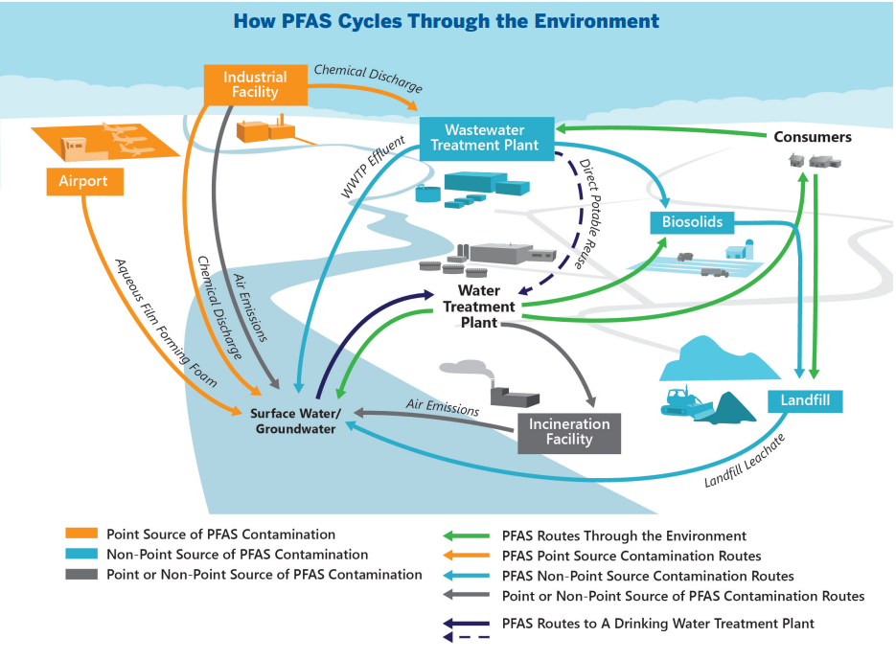
https://www.aaas.org/sites/default/files/2022-07/AAAS-EPI-Center_FactSheet__PFAS_0.pdf
Context & Trends:
- Health risks associated with PFAS include cancers, reproductive problems, and liver and thyroid issues https://www.atsdr.cdc.gov/pfas/about/health-effects.html
- PFAS were present in 45% of US drinking water in 2023 https://www.usgs.gov/news/national-news-release/tap-water-study-detects-pfas-forever-chemicals-across-us
PFAS were in 98% of tested water ways in 2024 https://waterkeeper.org/news/new-analysis-finds-pfas-in-98-of-tested-u-s-waterways-across-19-states/
95% of people tested since 1999 were found to have PFAS in their bodies https://www.atsdr.cdc.gov/pfas/hcp/clinical-overview/human-exposure.html
- Some PFAS are no longer produced in the US, but are still imported as consumer goods from elsewhere
- Landfills, AAAF firefighting foam, incineration, and wastewater treatment facilities (WWTFs) unintentionally contaminate our air and water https://www.aaas.org/sites/default/files/2022-07/AAAS-EPI-Center_FactSheet__PFAS_0.pdf
Solutions:
Research is ongoing to remove PFAS from biosolids produced by WWTFs that are used as fertilizer, which can contaminate grown crops. This can be mitigated by high-temperature treatment (gasification, pyrolysis, or incineration) of biosolids before agricultural use, according to several studies. https://www.sciencedirect.com/science/article/pii/S0048969724049222 https://pmc.ncbi.nlm.nih.gov/articles/PMC9128340/ https://www.hazenandsawyer.com/horizons/a-major-finding-for-biosolids-gasification-removes-all-detectable-pfas-from-finished-solids
Reverse osmosis membranes, granular activated carbon, and ion exchange resins can be used to remove PFAS from WWTF outflows. https://www.epa.gov/system/files/documents/2024-04/pfas-npdwr_fact-sheet_treatment_4.8.24.pdf
Dry sorbent injections with fabric filters or “wet scrubbers” can be installed to prevent emissions of PFAS into the air https://pfas-1.itrcweb.org/12-treatment-technologies/ https://www.epa.gov/system/files/documents/2024-04/2024-interim-guidance-on-pfas-destruction-and-disposal.pdf
Legislation to Watch:
- Some states are taking initiative by banning PFAS substances. https://www.saferstates.org/wp-content/uploads/PFAS-Upstream-State-Action.pdf

STEM POLICY UPDATES
Kentucky House Bill 102 (2025) died in committee in March 2025. It would have established a reporting requirement for manufacturers that intentionally include PFAS in products manufactured for sale or distribution in the Commonwealth. Efforts to improve reporting on the presence of PFAS in consumer products and reduction of their use over time can protect the long-term health and safety of Kentuckians.
Many scientists recognize PFAS contamination to be a clear and present danger to our communities. KAS supports additional testing and evidence-based mitigation measures.
Other states are responding by increasing testing of waterways, remediation and cleanup initiatives, and in some cases banning certain PFAS substances

RESOURCE OF THE MONTH
🔧 Interactive map showing areas in Kentucky with PFAS contamination:
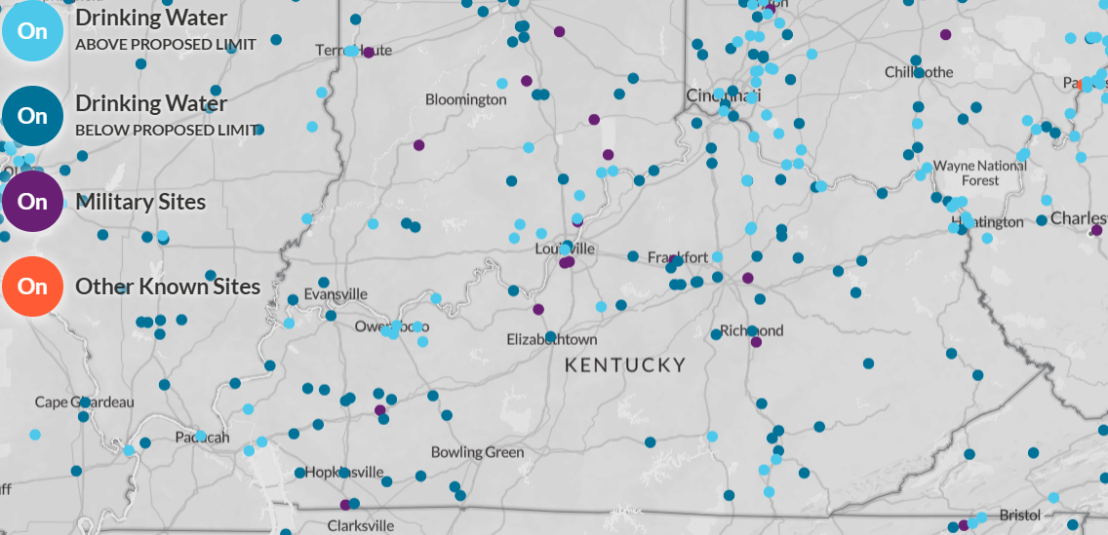

Want scientific input on a STEM policy bill?
Email us at policy@kyscience.org — we will present you with an evidence-based analysis of the bill and its implications for Kentuckians. We may even feature it in a future issue!

You're receiving this as a subscriber to the KY STEM Brief.
Feel free to forward and share with colleagues. If this was forwarded to you, you can subscribe here.

Kentucky Academy of Science
www.kyscience.org
PO Box 806 • Louisville, KY 40201
502-762-3472

