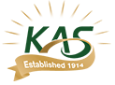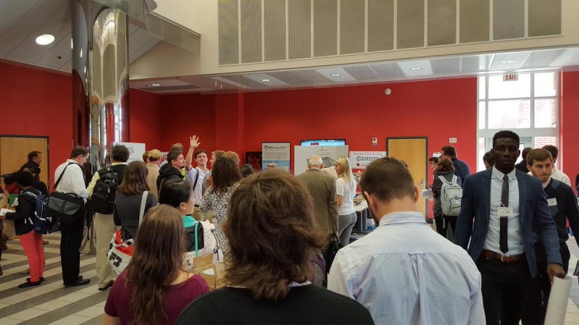
Think you can do better? Snap a photo for the…..

2019 Kentucky Academy of Science Social Media Picture Contest

Rules and Instructions

1. The Kentucky Academy of Science’s 2019 Social Media Picture Contest (“the Contest”) is open to all paid attendees of the 2019 Annual Meeting of the Kentucky Academy of Science (“KAS”) except the members of the KAS Governing Board and the Contest judges.

2. To enter the Contest, a contestant shall take a picture before or during the 2019 KAS Annual Meeting (held November 1- 2 in Berea, Kentucky) and publicly post it (so that KAS and the public have access to it) on Twitter, Instagram, or Facebook with the hashtag #TheSpiritOfKAS by 8:00pm (ET) Sunday November 3.

3. By entering, a contestant affirms that no laws were broken in creating or publishing his or her entry/entries, that the picture(s) are his or her own, and that the KAS has a permanent license to use the entry/entries as it sees fit.

4. After the Contest ends (8:00 pm EDT Sunday November 3), the entries will be judged by an ad hoc committee of judges. Each judge will grade each entry on a scale of 0-60 based on the following rubric:
KAS Social Media Picture Contest Judging Rubric
Criteria | Not at all |  | Barely |  | Somewhat |  | Pretty good |  |  | Impeccable
Photo is clear and of good quality | 1 | 2 | 3 | 4 | 5 | 6 | 7 | 8 | 9 | 10
Photo contains a KAS-related activity | 1 | 2 | 3 | 4 | 5 | 6 | 7 | 8 | 9 | 10
Photo is creative and visually appealing | 1 | 2 | 3 | 4 | 5 | 6 | 7 | 8 | 9 | 10
Photo conveys a positive image of Kentucky scientists | 1 | 2 | 3 | 4 | 5 | 6 | 7 | 8 | 9 | 10
Photo received 'likes' on Instagram or Twitter | 1 | 2 | 3 | 4 | 5 | 6 | 7 | 8 | 9 | 10
Photo features a well-written or creative caption | 1 | 2 | 3 | 4 | 5 | 6 | 7 | 8 | 9 | 10
Total Points:

5. If there is one entry with the highest total score, it will be declared the winner. In the event of a tie, the judges will determine the winner from among the tied entries. The decision of the judges is final.

6. The prize for the winning entry is a $50 gift card. The winning contestant will be announced and will have his or her picture featured on the KAS website and social media sites.

